Mary E. Heberle b 1927 d 2014 Webster NY

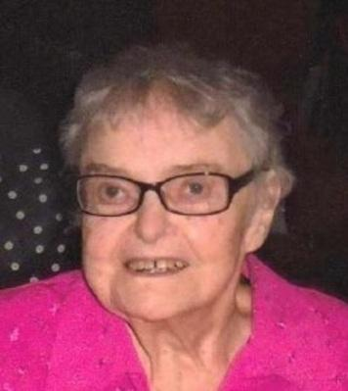
Heberle, Mary
Eileen (Emery)
Webster: Passed away peacefully on September 19, 2014. Predeceased by her son, Joey; and infant daughter, Maureen. Eileen is survived by her children, Mary Jo (James) Miller, Robert, James (Sue), Kathleen (John) Heberle, Ann (Tim) Habgood, Joan (David) Story, Maureen (William) Meng, Michael (Anja) and Bernard (Tatyana). Eileen was blessed with over 40 grandchildren & great-grandchildren. Eileen was a proud graduate of Our Lady of Mercy High School. She was a dedicated mother and grandmother.
Friends may call at Jennings, Nulton & Mattle Funeral Home, 1704 Penfield Rd., Monday, 4-8 PM. Eileen's Funeral Mass will be celebrated Tuesday, 11:15 AM at St. Rita's Church, 1008 Maple Dr., Webster. Interment, Holy Sepulchre Cemetery.

